Food Allergies



**Milk, eggs, soy, wheat, nuts, peanuts, fish, and shellfish are among the foods that cause the most allergies.**

**Young children who have food allergies tend to outgrow them with age, although this is not always the case. This largely depends on what food they are allergic to. There are some food allergies that are easier to overcome with age than others. Fish and shellfish allergies often appear later in a person’s life and are more difficult to overcome over time.**

**What are the most frequent allergens?**

**People can be allergic to any food, but the following eight allergens explain most food allergies:**

1. **eggs**
2. **peanuts**
3. **soy**
4. **wheat**
5. **nuts**
6. **fish**
7. **seafood**

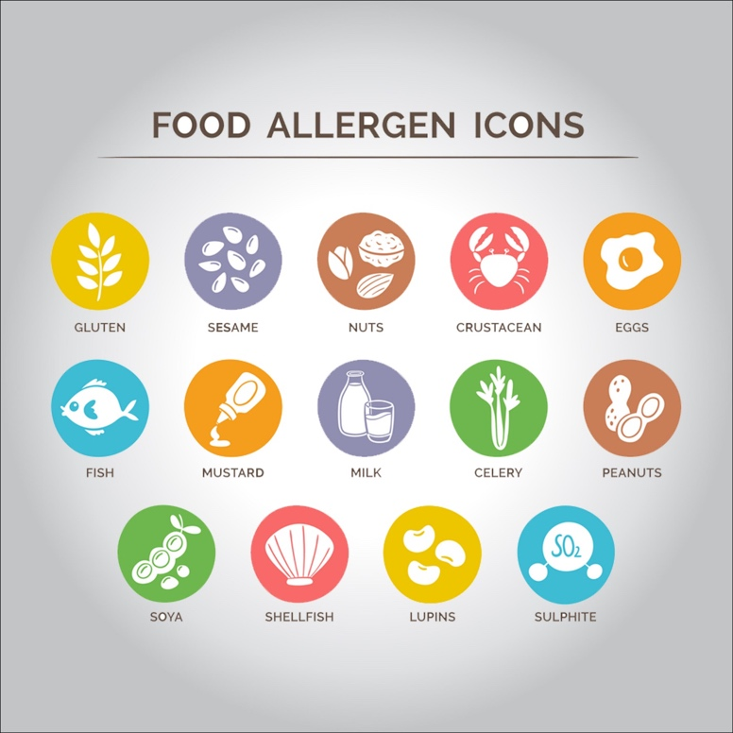

**What are the signs and symptoms of food allergies?**

**In food allergies, the body responds as if a particular food is harmful. Consequently, the immune system (which normally fights infection and disease) creates antibodies to fight the food allergen.**

**Every time a person eats (or, in some cases, manipulates or inspires) that food, their body releases chemicals like histamine.**

**These substances trigger allergic symptoms, including the following:**

* **wheezing**
* **shortness of breath**
* **cough**
* **hoarseness**
* **throat tightness**
* **abdominal pain**
* **vomiting**
* **diarrhea**
* **swollen, watery, and itchy eyes**
* **red beads**
* **inflammation**
* **a drop in blood pressure causing fainting or loss of consciousness (fainting)**

**People often confuse food allergies with food intolerance because they have similar symptoms. Symptoms of food intolerance include belching, indigestion, gas (or flatulence), loose stools, headache, nervousness, or a feeling of flushing. But food intolerance:**

* **does not affect the immune system**
* **can occur because a person is unable to digest a substance, such as lactose**
* **it can be unpleasant but it is only dangerous in very rare cases**

**Allergic reactions can affect any of the following areas of the body:**

1. **skin: itchy red pimples or welts (hives); eczema; redness and swelling of the face or extremities; itching and inflammation of the lips, tongue or mouth (skin reactions are the most common type of allergic reaction)**
2. **the digestive tract: abdominal pain, nausea, vomiting, or diarrhea**
3. **the respiratory system: nasal runny or stuffy nose, sneezing, coughing, wheezing (making “whistles” to breathing) or shortness of breath**
4. **the cardiovascular system: feeling light-headed or fainting**

**How are food allergies treated?**

**Food allergies cannot be cured, and the only real way to treat them is to avoid the food in question. But doctors can prescribe medications to help reduce allergic symptoms if they do occur, and even to save the person’s life if they have a severe allergic reaction.**

**Antihistamines allow treating isolated symptoms, such as hives, runny nose or abdominal pain associated with allergic reactions.**

**If your doctor diagnoses you with a severe allergy, he or she may prescribe epinephrine, which could be life-saving in case of anaphylaxis. Since it is important for the medication to enter the bloodstream quickly, epinephrine comes as an auto-injection.**

**If your doctor has prescribed epinephrine, you will need to carry the auto-injection with you wherever you go and always have one on hand at your home, your study center and the homes of the relatives and friends that you frequent the most.**

**So how do you know when to use epinephrine? Although your doctor will discuss this issue more extensively with you, the signs and symptoms of anaphylaxis include the following:**

* **hoarseness**
* **throat tightness**
* **inflammation of the mouth**
* **shortness of breath**
* **any combination of two or more symptoms belonging to two or more body systems (skin, heart, lungs, etc.), such as hives added to belly pain**
* **any other combination of two or more symptoms that affect various parts of the body**